Applied example 2

Alex Pate

2024-12-12

### Load libraries  
library(pmsampsize)  
library(samplesizedev)  
  
### Set seed  
set.seed(555)  
  
### C 0.65  
C_adj <- 0.65  
prop <- 0.05  
n_param <- 5  
  
nreq.pavlou <- try(samplesizedev(S = 0.9, phi = prop, c = C_adj, p = n_param, nsim = 1000))

## [1] "Optimisation Starting, ~ 1 min left..."

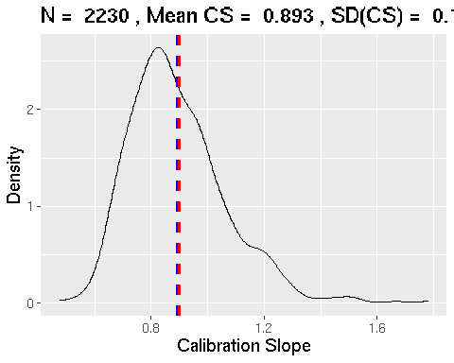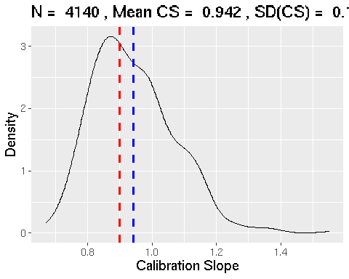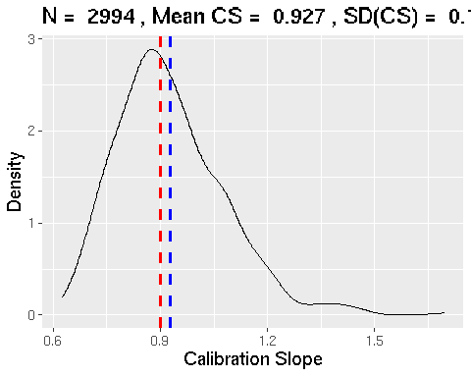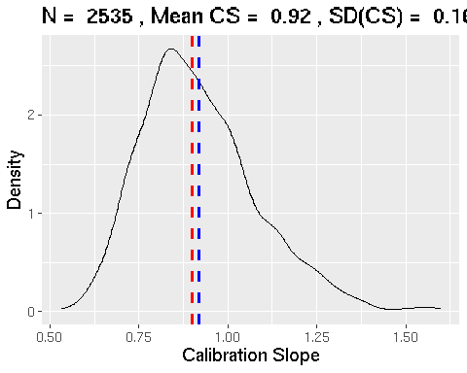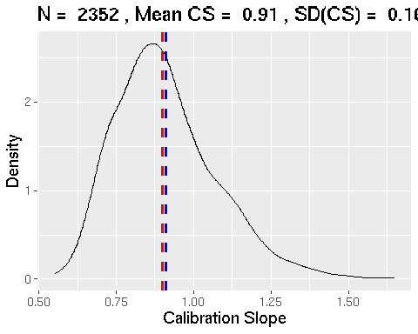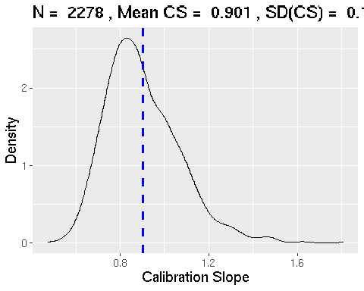

nreq.pavlou

## $rvs  
## [1] 3185  
##   
## $sim  
## [1] 2280

nreq.riley.c <- as.numeric(pmsampsize(type = "b",   
 cstatistic = C_adj,   
 parameters = n_param,   
 shrinkage = 0.9,   
 prevalence = prop)$results_table["Criteria 1", "Samp_size"])  
nreq.riley.c

## [1] 3236

### C 0.71  
C_adj <- 0.71  
prop <- 0.05  
n_param <- 13  
  
nreq.pavlou <- try(samplesizedev(S = 0.9, phi = prop, c = C_adj, p = n_param, nsim = 1000))

## [1] "Optimisation Starting, ~ 1 min left..."

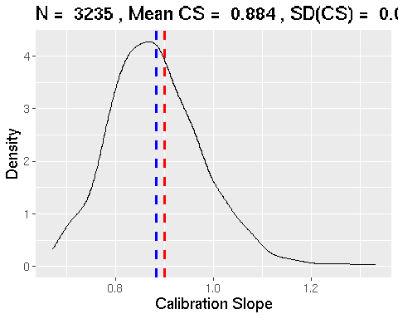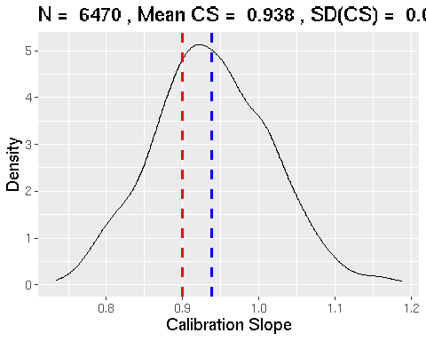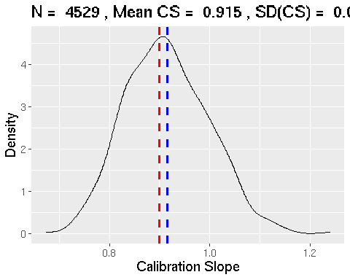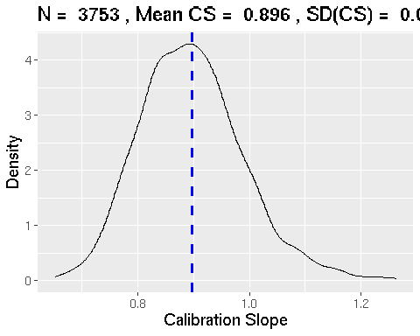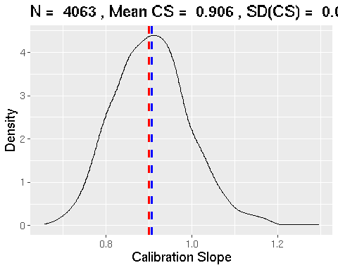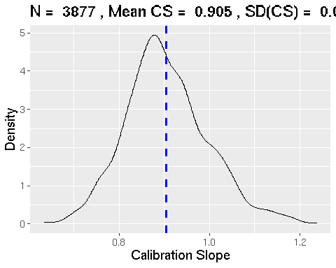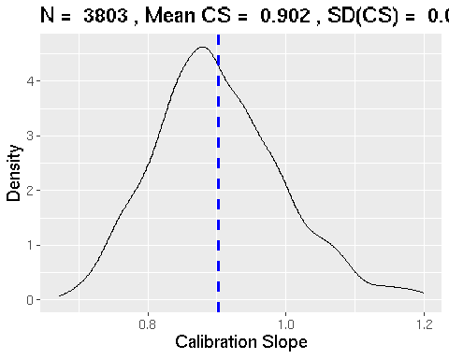

nreq.pavlou

## $rvs  
## [1] 4044  
##   
## $sim  
## [1] 3820

nreq.riley.c <- as.numeric(pmsampsize(type = "b",   
 cstatistic = C_adj,   
 parameters = n_param,   
 shrinkage = 0.9,   
 prevalence = prop)$results_table["Criteria 1", "Samp_size"])  
nreq.riley.c

## [1] 4114

### C 0.85  
C_adj <- 0.85  
prop <- 0.05  
n_param <- 23  
  
nreq.pavlou <- try(samplesizedev(S = 0.9, phi = prop, c = C_adj, p = n_param, nsim = 1000))

## [1] "Optimisation Starting, ~ 1 min left..."

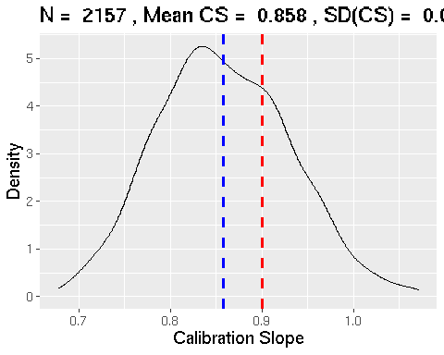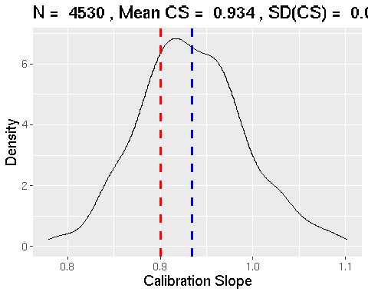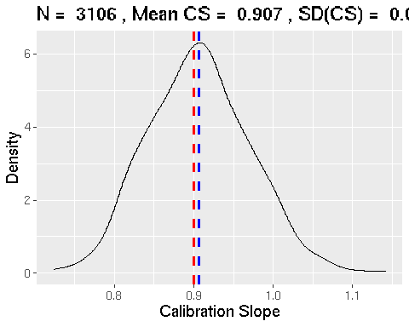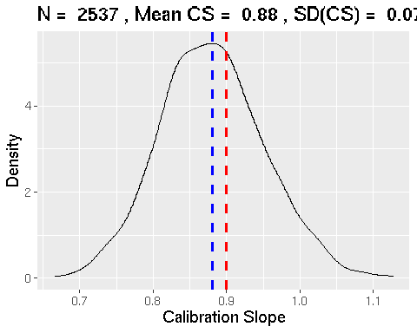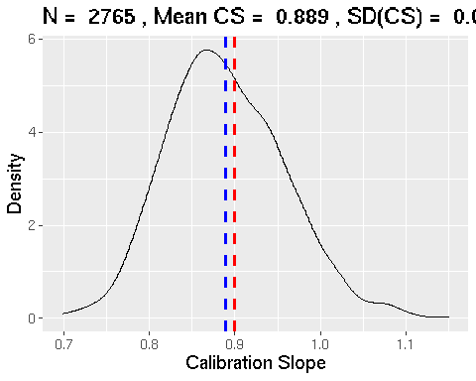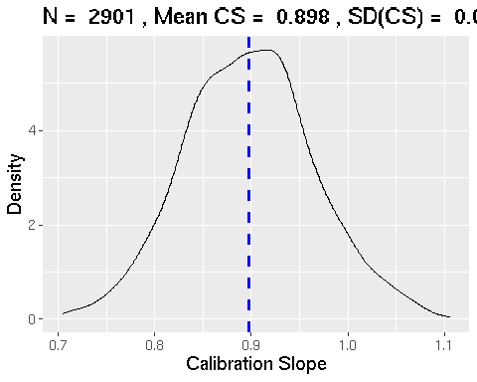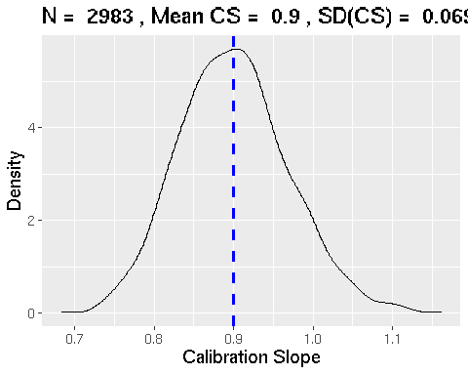

nreq.pavlou

## $rvs  
## [1] 2157  
##   
## $sim  
## [1] 2985

nreq.riley.c <- as.numeric(pmsampsize(type = "b",   
 cstatistic = C_adj,   
 parameters = n_param,   
 shrinkage = 0.9,   
 prevalence = prop)$results_table["Criteria 1", "Samp_size"])  
nreq.riley.c

## [1] 2183